

* **Human Rights Policy**
* A Fair Place to Work
* Promoting Health & Safety For Workers & Communities
* Supports the inclusion of Women across palm oil operations.

Freedom of Association

Refers to the right of a person to join a group and also leave the group voluntarily. This right is guaranteed by modern human rights instruments and the 1945 Constitution article 28 E paragraph 3.

AEP respects and provides freedom of association and non-discrimination for every employee to join a trade union of his choice to help workers express their aspirations. freedom of association is required by the ISPO principles and criteria.

The names of the trade unions in AEP are as follows:

* SPSI (Serikat Pekerja Seluruh Indonesia)
* Serikat Pekerja Perkebunan Graha mandiri
* Serbundo (Serikat Buruh Indonesia)
* Serikat Pekerja Puding Alno RAA Mandiri
* Etc.

**Non- Discrimination**

We operate on the basis of equal opportunities and our employees receive the same pay and benefits regardless of gender. Around 26% of our employees are women and in the future all sites will be establish gender committees to ensure that issues of particular concern for women are raised and addressed. AEP fully supports women taking on careers traditionally dominated by men, such as manuring foreman, spray foreman, FFB clerk, etc. This gender equality is appreciated by men and serves as encouragement to other women across our operations.

**Training to employees on its Human Rights Policies**

We always provide training and understanding related to Human Rights which we include in the sustainability policy, namely:

* No Deforestation, No Peat, and No Exploitation Policy (NDPE)
* Best Management Practice
* No Forced or Bound Labour
* No Child Labour
* Employee Health and Safety
* Fair Employment Terms
* Whistle Blowing
* Rights of Indigenous People and Local Communities

Rights For Workers

* All employees have the right to join and form organisations of their own choosing and to bargain collectively
* No children below 18 working paid or unpaid on our premises. We will seek to ensure that schooling opportunities are available to children in the areas where we operate
* No bonded or forced labour. Withholding of personal documents or other bonds is prohibited
* Equal opportunities. Discrimination based on any grounds in recruitment, dismissal or promotion is strictly banned.

**Rights to Health**

We endeavour to support the safety and health of our community through:

* Comprehensive occupational health and safety improvement plans
* Decent housing
* Availability of clean water
* Personal Protective Equipment
* Programmes for the prevention of Covid-19 and support of those affected
* A ban on sexual harassment

nesciunt, neque porro quisquam est, qui dolorem ipsum, quia dolor sit, amet, consectetur, adipisci velit, sed quia non numquam eius modi tempora incidunt, ut labore et dolore magnam aliquam quaerat voluptatem. ut enim ad minima veniam.

Lorem ipsum dolor sit amet, consectetuer adipiscing elit, sed diam nonummy nibh euismod tincidunt ut laoreet dolore magna aliquam erat volutpat. Ut wisi enim ad minim veniam, quis nostrud exerci tation ullamcorper suscipit lobortis nisl ut aliquip ex ea commodo consequat. Duis autem vel eum iriure dolor in hendrerit in vulputate velit esse molestie consequat, vel illum dolore eu feugiat nulla facilisis at vero eros et accumsan et iusto odio dignissim qui blandit praesent luptatum zzril delenit augue duis dolore et feugiat nulla facilisis.

Duis autem vel eum iriure dolor in hendrerit in vulputate velit esse molestie consequat, vel illum dolore eu feugiat nulla facilisis at vero eros et accumsan et iusto odio dignissim qui blandit praesent luptatum zzril delenit augue duis dolore et feugiat nulla facilisis.

Lorem ipsum dolor sit amet, consectetuer adipiscing elit, sed diam nonummy nibh euismod tincidunt ut laoreet dolore magna aliquam erat volutpat. Ut wisi enim ad minim veniam, quis nostrud exerci tation ullamcorper suscipit lobortis nisl ut aliquip ex ea commodo consequat. Duis autem vel eum iriure dolor in hendrerit in vulputate velit esse molestie consequat, vel illum dolore eu feugiat nulla facilisis at vero eros et accumsan et iusto odio dignissim qui blandit praesent luptatum zzril delenit augue duis dolore et feugiat nulla facilisis.

Duis autem vel eum iriure dolor in hendrerit in vulputate velit esse molestie consequat, vel illum dolore eu feugiat nulla facilisis at vero eros et accumsan et iusto odio dignissim qui blandit praesent luptatum zzril delenit augue duis dolore et feugiat nulla facilisis.

**SR, FR & Fatalities (AEP Group)**

**A Safe Workplace**

The main goal of safety and health programs is to prevent workplace injuries, illnesses, and deaths, as well as the suffering and financial hardship these events can cause for workers, their families, and employers. Our practice is to use a proactive approach to managing safety and health in the workplace. Traditional approaches are often reactive –that is, problems are addressed only after a worker is injured or becomes sick, a new standard or regulation is published, or an outside inspection finds a problem that must be fixed.

With that finding and fixing hazards before they cause injury or illness is a far more effective approach.

Safety and health programs help businesses:

* **Prevent** workplace injuries and illnesses
* **Improve** compliance with laws and regulations
* **Reduce** costs, including significant reductions in workers' compensation premiums
* **Engage** workers
* **Enhance** their social responsibility goals
* **Increase** productivity and enhance overall business operations

We have an EHS team in each unit to ensure the implementation of the safety and health program goes well. Every month EHS makes a monthly report related to the results of K3LH monitoring and inspection which is submitted to Top Management.

Regular P2K3 meetings are held by unit management involving staff and employees to discuss the improvement of safety and health performance that has been implemented properly, and any EHS findings will be discussed for immediate corrective action.

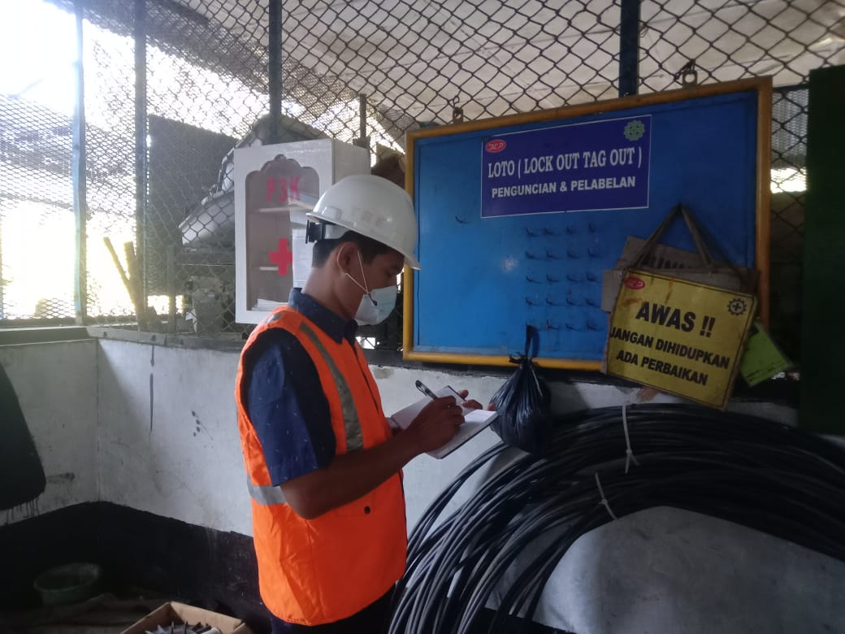

Training for Women

Employee performance evaluation is always carried out by the Company. This is done to determine the ability to assess as well as to find out what development needs will be carried out by the company for employees. All of this aims to make the Company sustainable and able to compete with other companies, which is based on the creation of trained workers. The capacity development program or human resource improvement program applies to all workers regardless of gender.

Especially for female workers, several consistent trainings are carried out, namely training on the use of pesticides on plantations, fertilization application techniques, administrative training, Hyperkes training for medical personnel, computer program application training, etc.

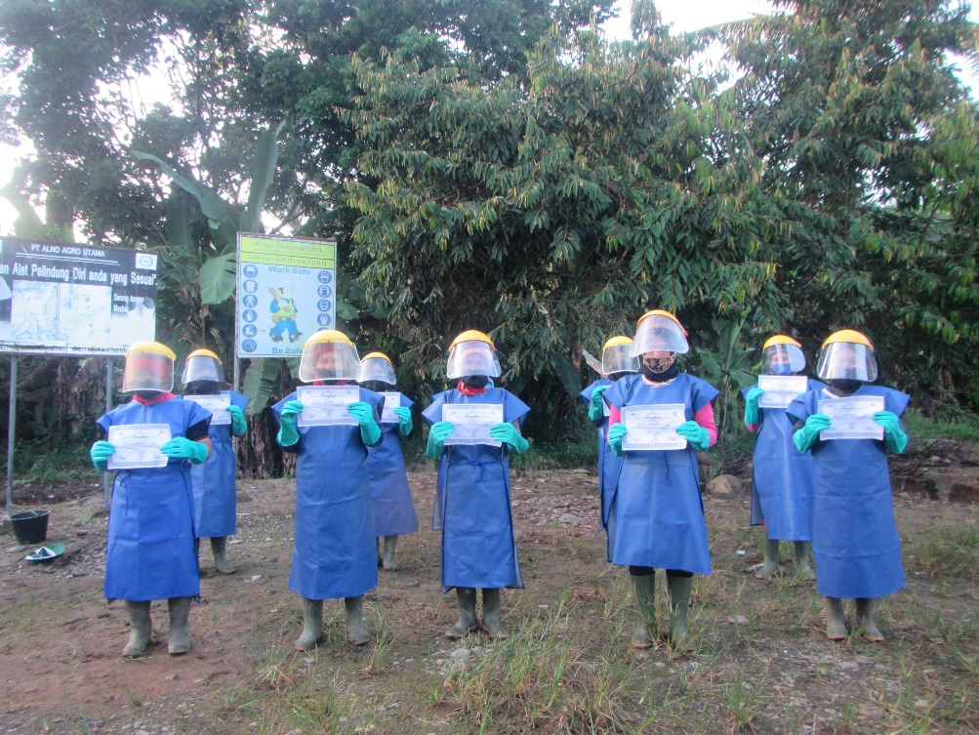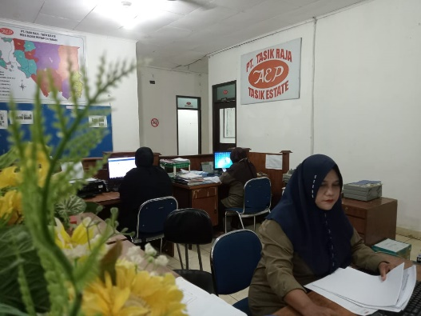

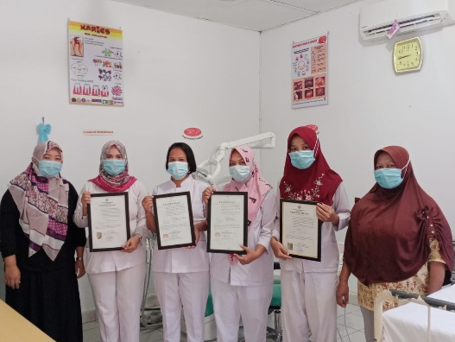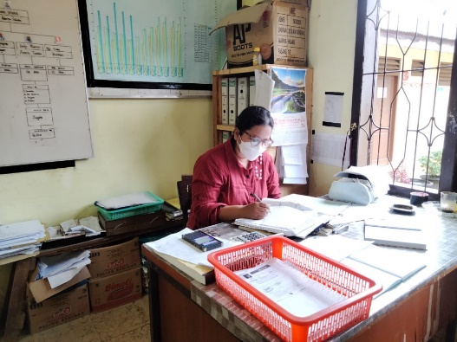

**Gender Committee of AEP**

The Gender Committee is generally motivated by the prevention and control of violence against women and the elimination of all forms of violence against women. In particular, due to the company's concern to ensure the rights of female employees to continue working with a safe and comfortable feeling. Our own company shows concern about this by issuing a policy on sexual violence. With the establishment of Gender Committees in all AEP operating units, it is hoped that it will reduce the chances of sexual violence occurring in order to foster a safe and comfortable working environment.

*The benefits and objectives of the establishment of this gender committee are as follows:*

* Ensuring the smooth working of employees is safe from all forms of violence against women and the enforcement of women's human rights
* The gender committee develops cooperation between employers and management on the one hand and the workforce, especially female workers on the other hand in carrying out joint obligations, especially in terms of handling sexual violence issues.
* Accommodate and evaluate issues raised by women workers, as well as opinions related to sexual violence issues and assist employers or management in implementing sexual violence prevention programs
* Provide new knowledge and inspiration for female employees needed for the maintenance of safe working conditions without sexual violence
* Increase efforts to prevent and overcome all forms of violence against women and protect women's human rights.

*The main functions and duties of our gender committee are:*

1. Conducting socialization to all female workers in the company, providing explanations and knowledge of the laws relating to sexual violence
2. Provide advice, whether requested or not, to employers/workplace administrators regarding sexual violence issues
3. Reporting the results of meetings or discussions that are held routinely and/or non-routinely, to the company for which preventive action can be taken
4. Collect and process all grievance or complaints related to sexual violence in the workplace and company environment
5. Provide a sense of security to victims of sexual violence in submitting grievances or complaints of sexual violence against female employees.